|  |  |
| --- | --- |
|  | Student Name _______________________    **Eastern Goldfields College**  Mathematics Applications 2019  Test 5 (U2 T2) – Calculator Free1 |
|  | **Total Marks: 26 marks** |

**Time allowed: 20 minutes**

**No calculator or notes permitted for this section.**

***Show all working where appropriate to obtain full marks.***

**Question 1** **(5 marks: 1, 2, 2)**

State the **gradient** and the **co-ordinates** of the **y intercept** of each of the following straight lines.











$y=4-5x$

$3y=6x-2$

$2x+2y=10$

Question 2 (4 marks: 2, 2)

1. Give the true bearing of B from A. **b)**  Give the compass bearing of A from B.

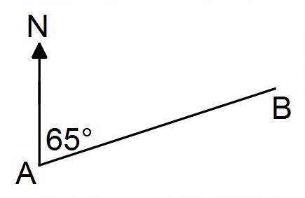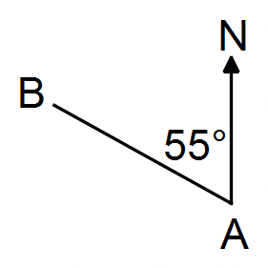

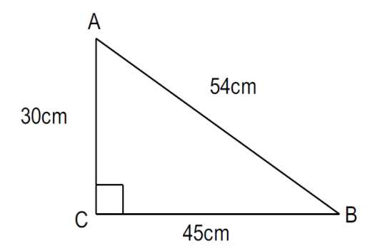**Question 3**  **(2 marks: 1, 1)**

Consider the triangle *ABC*.

a) Determine the value of 𝑠𝑖𝑛 ∠ 𝐵𝐴𝐶.

b) If the lengths of the sides of the triangle were all doubled in size, how would this effect the value of 𝑠𝑖𝑛∠ 𝐵𝐴𝐶?

**Question 4** **(5 marks: 2, 3)**

Katie was 15m due south of Steph. Mitch is due east of Katie and on a bearing of 158° from Steph.

1. Draw a labelled diagram to represent the above information.

1. Calculate the distance between Katie and Mitch. **Hint:** *tan22 = 0.4 (approximately)*

**Question 5 (10 marks: 2, 2, 4, 1, 1 )**

Billy charged $20 per hour for gardening.

(a) Write the relationship between total cost (C) and number of hours worked (t) by Billy.

Johnny charged $50 to bring his truck to cart rubbish away and then $15 an hour to do

the gardening.

(b) Write the relationship between total cost (C) and number of hours worked (t) by

Johnny.

(c) Sketch both relationships on the set of axes below. Label each graph.

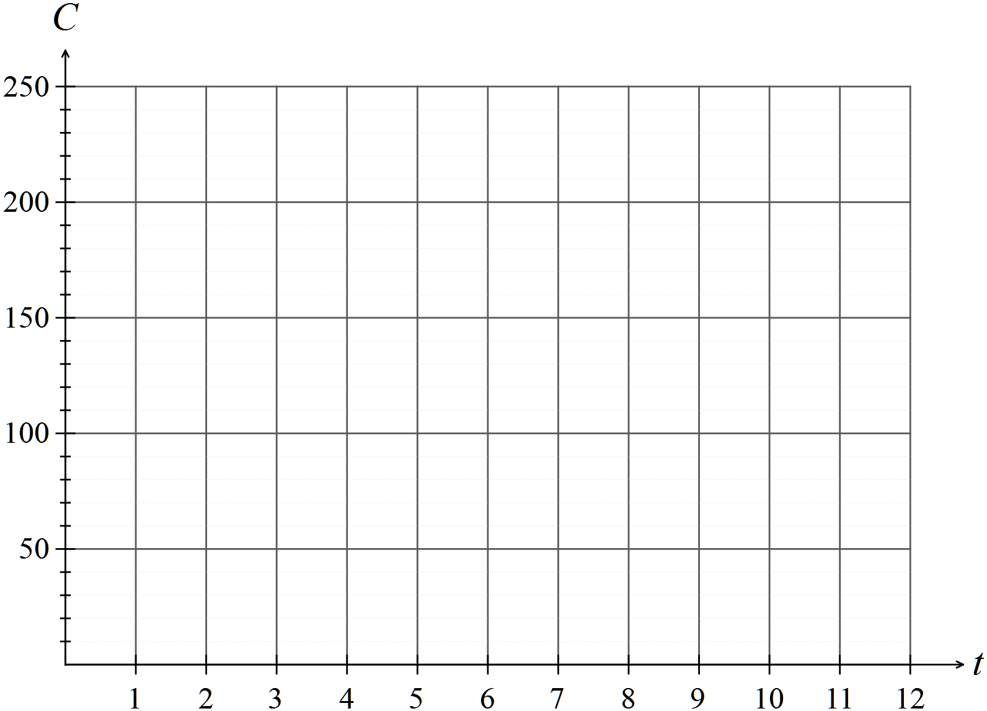

(d) Which man is the cheaper for 7 hours work?

(e) After how many hours are the costs the same?

**End of Non-Calculator Section**

|  |  |
| --- | --- |
|  | Student Name _______________________    **Eastern Goldfields College**  Mathematics Applications 2019  Test 5 (U2 T2) – Calculator Assumed1 |
|  | **Total Marks: 33 marks** |

**Time allowed: 35 minutes**

**Calculator and 1 x double sided A4 notes permitted for this section.**

***Show all working where appropriate to obtain full marks.***

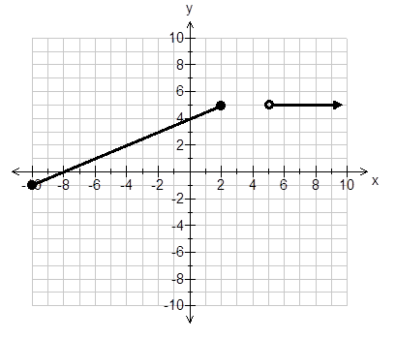**Question 6** **(8 marks: 2, 2, 4)**

Consider the piecewise function shown.

1. For what values of 𝑥 is 𝑦 = 5?

m =

m =

1. Label each of the gradients for each

section of this graph.

1. Write functions to define the graph   
   shown.

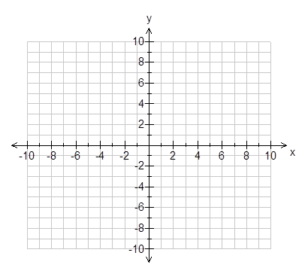

**Question 7** **(5 marks: 3, 2)**

Graph the following functions on the

axes provided.



$y= -x+1; -7<x<5$

$x=10; y≥-5$

**Question 8** **(5 marks: 3, 2)**

Aimee and Claire are playing hide and seek with Sam in the park. Sam will be seeking. Aimee

leaves Sam on a bearing of 116 degrees and goes 23m to hide. Claire leaves Sam and goes

35m on a compass bearing of South 12O East to hide. Claire and Aimee’s hiding spots are 19m apart.

1. Draw a diagram of this situation
2. What bearing does Claire have to take to return back to Sam?

**Question 9** **(4 marks)**

Calculate the value of the unknown side in the following right-angled triangle. Round your answer to 1 decimal place.

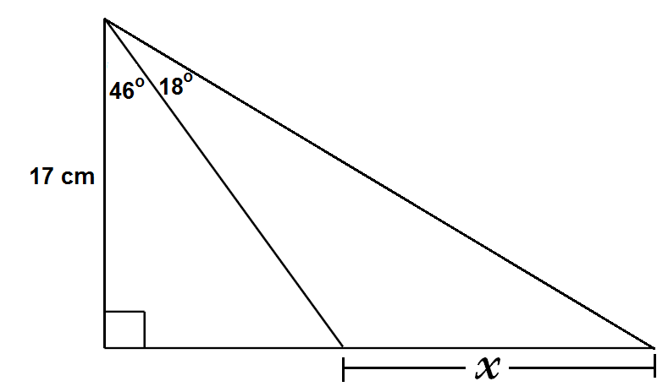

**Question 10** **(4 marks: 2, 2)**

A 2.2 metre ladder leans against the top of a 1.8 m tall wall.

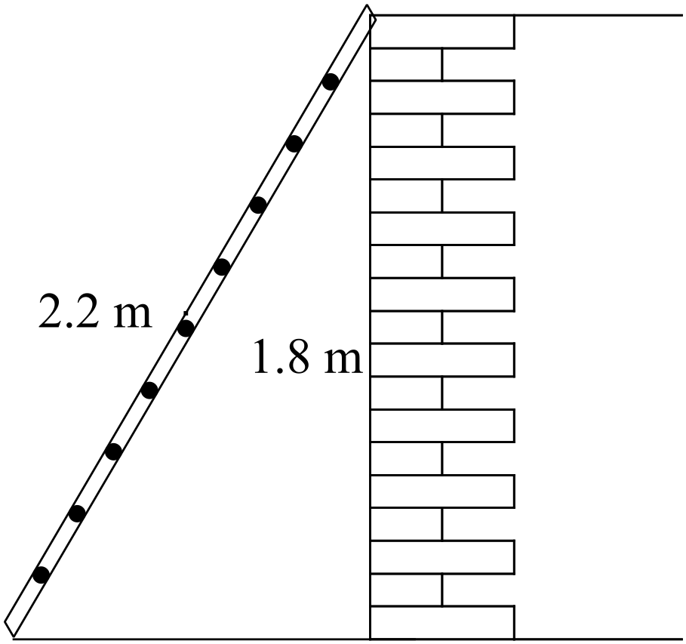

a) What angle does the ladder make with the ground?

b) Use trigonometry to determine how far the base of the ladder is from the wall.

**Question 11** **(7 marks: 1, 2, 1, 3)**

A children’s slide at the park can have a maximum angle of elevation of 31 degrees according to council regulations.

A 2.5m slide is erected in a park with the maximum slope.

a) Draw a diagram of this slide.

b) Determine the height of the slide.

The playground engineer wants to make a second slide. He wants it to be 1.3m high and 2.2m long.

c) Draw a diagram of this slide.

d) Does this second slide pass council regulations?

**End of Calculator Section**